**Windows Server – Part 1**

Machines:

1 Windows Server 2016 and 1 Windows 10 Client Machine

**Part 1: Setup and Configure Your Server Image**

**\*\*HARDWARE, OS INSTALL, INIT SETUP INFO HERE\*\***

* If you get a box asking about connecting to the network, click Yes.

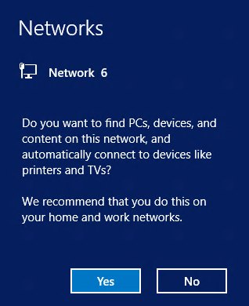

* **First**, do this. Server Manager > Tools > Computer Management > Local Users & Groups > Users > Administrator > **Uncheck ‘User must change password at next login’** and set **Password never expires for the Administrator account**.
* Now go back to the Server Manager select Local Server, and then click on the current computer name to open the System Properties window.

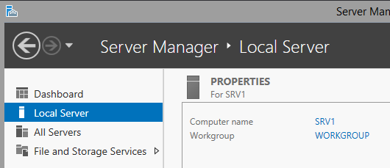

* In Server Properties, click on Change to change the computer name. NOTE: The Computer Description box is NOT for the computer name. You have to click Change to get to the proper place to actually change the name of the computer. Set the computer name and the Workgroup name to YOUR DOMAIN. You will be required to restart the image after changing the name.

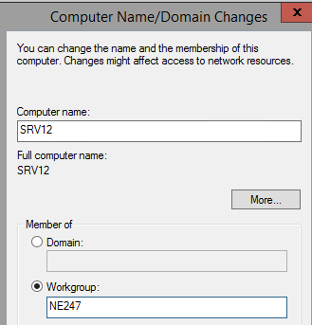

* After rebooting, log back on as Administrator and close Server ManageR when it starts. (You can always reopen Server Manger later by using the icon next to the start button.)
* Right click on the **Start Menu** button and select **Command Prompt/Powershell.** Be sure to open as admin.

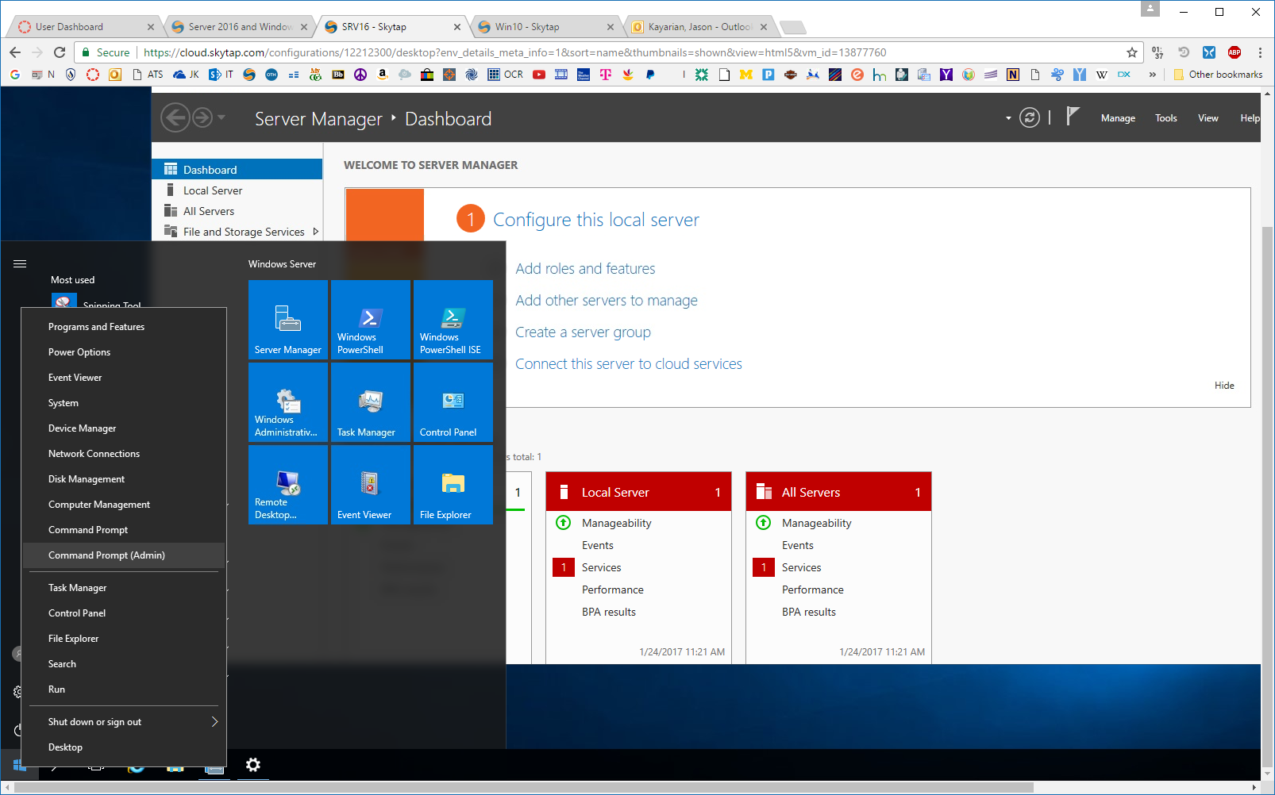

* In the Command Prompt, issue the **ipconfig /all** command and record what you see. You will need to refer to this later. *(Note: The DNS entries you see won’t be labeled Preferred and Alternate, but that is what they represent, so the table below shows those names.)*

IPV4 Address: **_______________________________**

Default Gateway: **_______________________________**

Subnet Mask: **_______________________________**

Preferred DNS **_______________________________**

Alternate DNS **_______________________________**

* Right click on the clock in the lower right corner of the Task Bar, select Adjust Date/Time and then verify the Time Zone to your given time zone. During a standard installation, Windows sets the Time Zone to Pacific Standard time.

In the next section you will set or verify that certain services are set to run every time the server boots up. This is done to be sure that the server will be visible to other computers on the network when they browse the network.

* On **SRV16** go to **Start** -> **Server Manager** -> **Tools** menu in Server Manager and select the **Services** option.
* In the list of services, scroll down to the **Function Discover Resource Publication** service and double click on it. (*There are two different Function Discovery services; be sure to pick the correct one.*)
* Verify that the server is set to Automatic and click the Start button

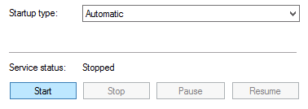

* After the service starts, click OK.
* Locate the **SSDP Discovery** service, set it to start automatically and start it and click OK.
* Repeat the process for the **UPnP Device Host** service.
* Using Server Manager > Tools > Computer Management > Disk Management to review disk configuration.

Part 2: Prepare Windows 10 Client Image

**\*\*HARDWARE, OS INSTALL, SETUP GOES HERE\*\***

* + Setup with a local account and password
  + Computer Management > Disk Management to review disk configuration.
  + Open System settings by clicking on the File Explorer [Folder] icon on the Taskbar, then right clicking on This PC and select Properties.
  + Across from Computer Name click on **Change settings.**
  + Click the **Change Settings** button and set the workgroup name to the domain as you did on your server image. Also verify the computer name here.
  + After clicking on OK you will have to restart your client computer and log back in again.
  + Open a command prompt and issue the IPCONFIG command, then record what you see. (You may want to pin the Command prompt to the taskbar as you did with the server.)

IPV4 Address: **_______________________________**

Default Gateway: **_______________________________**

Subnet Mask: **_______________________________**

* + Shut the client computer down by first right clicking on the Start menu then selecting Shut down or sign out and choosing Shut down.

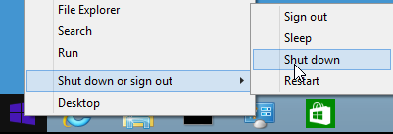

* + Shut down your server image.